

Year 11 Units 1 & 2 Examination, 2018

Question/Answer Booklet

CHEMISTRY

Student Name: ______________________________________________

Teacher Name: QUESTIONS

Time allowed for this paper
Reading time before commencing work: ten minutes
Working time for paper: three hours

Materials required/recommended for this paper

To be provided by the supervisor
This Question/Answer Booklet
Multiple-choice Answer Sheet
Chemistry Data Sheet

To be provided by the candidate
Standard items: pens (blue/black preferred), pencils (including coloured), sharpener, correction tape/fluid, eraser, ruler, highlighters
Special items: up to three non-programmable calculators approved for use in the ATAR examinations

Important note to candidates
No other items may be taken into the examination room. It is your responsibility to ensure that you do not have any unauthorised notes or other items of a non-personal nature in the examination room. If you have any unauthorised material with you, hand it to the supervisor before reading any further.
Structure of this paper

Section | Number of questions available | Number of questions to be answered | Suggested working time  (minutes) | Marks available | Percentage of examination
Section One:  Multiple-choice | 25 | 25 | 50 | 50 | 25
Section Two:  Short answer | 8 | 8 | 60 | 70 | 35
Section Three:  Extended answer | 4 | 4 | 70 | 80 | 40
Total |  |  |  |  | 100

Instructions to candidates

1. Answer the questions according to the following instructions.

Section One: Answer all questions on the separate Multiple-choice Answer Sheet provided. For each question shade the box to indicate your answer. Use only a blue or black pen to shade the boxes. If you make a mistake, place a cross through that square, do not erase or use correction fluid, and shade your new answer. Marks will not be deducted for incorrect answers. No marks will be given if more than one answer is completed for any question.

Sections Two and Three: Write answers in this Question/Answer Booklet.

3. When calculating numerical answers, show your working or reasoning clearly. Express numerical answers to the appropriate number of significant figures and include appropriate units where applicable

4. You must be careful to confine your responses to the specific questions asked and to follow any instructions that are specific to a particular question.

5. Spare pages are included at the end of this booklet. They can be used for planning your responses and/or as additional space if required to continue an answer.
• Planning: If you use the spare pages for planning, indicate this clearly at the top of the page.
• Continuing an answer: If you need to use the space to continue an answer, indicate in the original answer space where the answer is continued, i.e. give the page number. Fill in the number of the question that you are continuing to answer at the top of the page.
Section One: Multiple-choice 25% (25 Marks)

This section has 25 questions. Answer all questions on the separate Multiple-choice Answer Sheet provided. For each question shade the box to indicate your answer. Use only a blue or black pen to shade the boxes. If you make a mistake, place a cross through that square, do not erase or use correction fluid, and shade your new answer. Marks will not be deducted for incorrect answers. No marks will be given if more than one answer is completed for any question.

Suggested working time: 50 minutes.

1. As we move across a period in the periodic table form left to right:

- The atomic radii of the elements increases
- The metallic character of the elements increases
(c) the number of electron shells in each element increases
(d) the tendency of each element to gain electrons increases

2. The electron configuration for potassium is:

(a) 1s² 2s² 2p⁶ 3s² 3p⁶ 4s¹
(b) 1s² 2s² 2p⁸ 3s¹ 3p⁶
(c) 1s² 2s² 2p⁶ 3s² 3p⁶ 4s²
(d) 1s² 2s⁸ 3s⁸ 4s¹

3. Which one of the following is the correct name for the compound shown below?

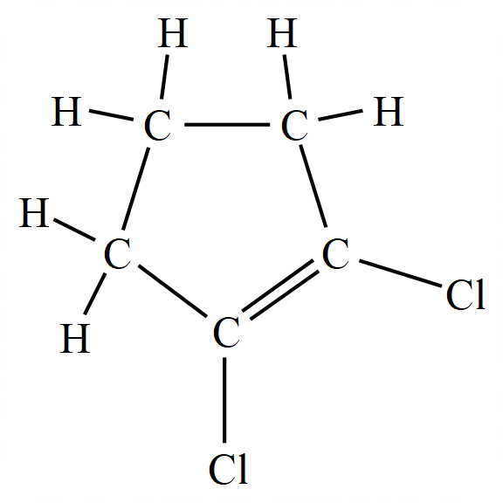

(a) 1,2-dichlorocyclopentane
(b) 1,2-dichlorocyclopentene
(c) 1,2-chlorocyclopent-1-ene
(d) dichlorocyclopentene

4. Which one of the below is the structural formula for 2,4-dimethylpent-2-ene?
(a) | 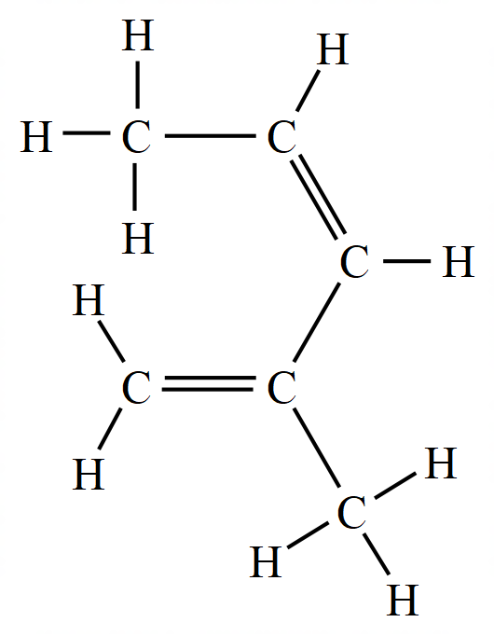
(b) | 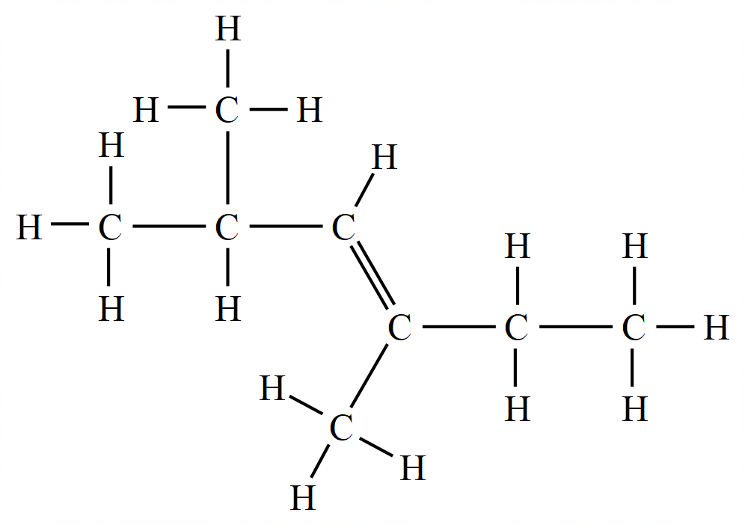
(c) | 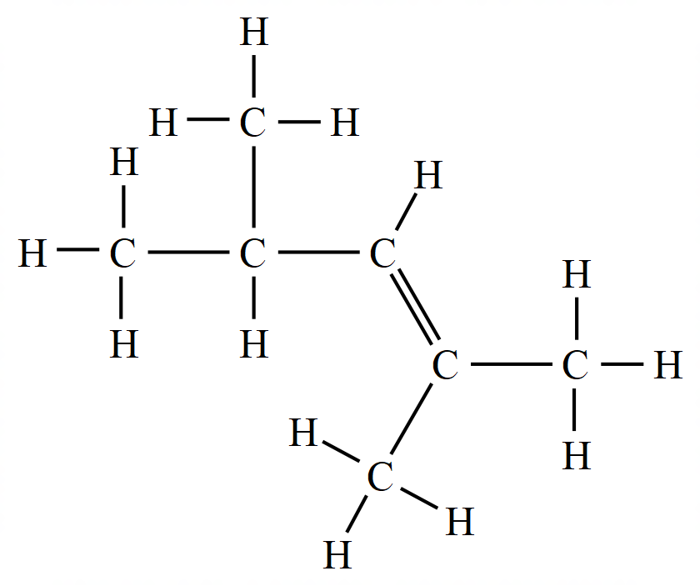
(d) | 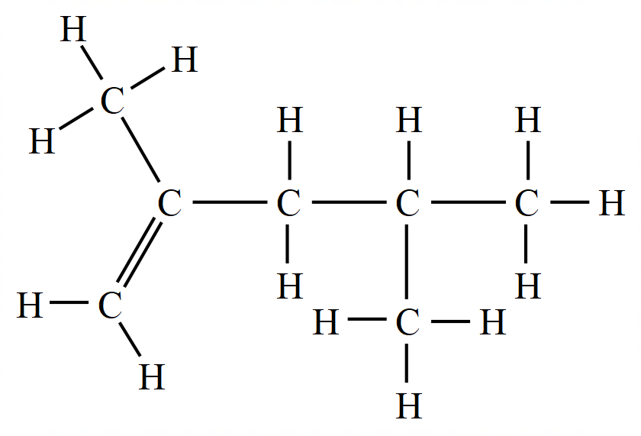

5. Graphite and diamond are allotropes of carbon because:

(a) their atoms are arranged differently
(b) the atoms in each have different numbers of electrons
(c) one has covalent bonds the other has ionic bonds
(d) they form different types of oxides when burnt in air

6. Which one of these is the correct formula for ammonium hydrogen carbonate?

(a) (NH₄)₂CO₃ . H₂O
(b) NH₄HCO₃
(c) (NH₄)₂HCO₃
(d) NH₃HCO₃

7. Which of the following does not have the same number of electrons?

(a) Mg²⁺ and O²⁻
(b) K⁺ and C⁻
(c) Ca²⁺ and Ar
(d) H⁺ and He

8. Bonding in the solid ammonium nitrate involves:

- Ionic bonds
- Covalent bonds
- Metallic bonds

(a) I only.
(b) I and II.
(c) II and III.
(d) II only.

9. Which statement about the Group II elements is/are correct?

- Atomic Radii of Group II elements increases down the group
- Electronegativity Group II elements increases down the group
- Ionisation Energy of Group II elements decreases down the group

(a) III only
(b) I and III
(c) II and III
(d) I, II and III

10. Nanoparticles are particles that have a size between 1 – 100 nm. (where 1 nm (nanometre) = 1 × 10⁻⁹ m). Which one of the flowing would be classified as a nanoparticle?

  - a radon atom
  - an octane molecule
  - a particle of gold containing a few thousand atoms
  - a section of the molecular network in piece of graphite

11. Which of the following is most likely to be a pure compound?

(a) a white powder which partially dissolves in pure water
(b) green crystals which melt at exactly 58ºC
(c) blue crystals that melt between 55ºC and 60ºC
(d) a liquid that gives two fractions when distilled

12. Which of the following provides evidence for kinetic particle theory?

(a) a small mass of water produces much larger volume of steam.
(b) a thin layer is formed when an oil drop is placed on water.
(c) all gases may be easily compressed when a force is applied.
(d) the smell of perfume quickly spreads across a room.

13. The solubility of three substances in two different solvents (P and Q) are shown in the table below
Solid | Solvent
Solid | P | Q
Sand | Insoluble | Insoluble
Sulfur | Soluble | Insoluble
Salt | Insoluble | soluble

A mixture of three solids; sand, sulfur and salt are subjected to the following procedures:
- Excess solvent P added to the solid mixture
- Filtered with the residue collected and labelled as X
- Excess solvent Q was then added to residue X
- This was filtered and the filtrate collected and labelled as Y

Which of the following correctly describes filtrate Y:

(a) Y contains salt only
(b) Y contains sand only
(c) Y contains sulfur only
(d) Y contains a mixture of sand and sulfur

14. Select the most correct way to complete this statement:
During the fractional distillation of crude oil the mixture of hydrocarbons…

(a) cools as it rises through the column
(b) is able to be separated due to differing melting points of its components
(c) is separated by selective boiling
(d) is separated due to differing densities

15. A solution of ammonium sulfate reacts with a solution of calcium hydroxide to produce ammonia gas, calcium sulfate and water as outlined in the equation below:

(NH₄)₂SO₄ (aq) + Ca(OH)₂ (aq) → 2 NH₃ (g) + CaSO₄ (s) + 2 H₂O ()

If 4 moles of ammonia gas were collected after completely reacting all of the ammonium sulfate, how many moles of nitrogen must have been present in the ammonium sulfate reactant?

(a) 1 mole
(b) 2 moles
(c) 4 moles
(d) 8 moles

16. When a uranium nitrate salt UO₂(NO₃)₂ is heated it decomposes to yield uranium oxide (U₃O₈), nitrogen dioxide (NO₂) and oxygen (O₂). How many moles of O₂ are obtained from one mole of the salt?

(a) 1/3 moles
(b) 1/2 moles
(c) 2/3 moles
(d) 2 moles

17. Which one of the following pairs of solutions when mixed together will NOT form a precipitate?

(a) sodium nitrate and hydrochloric acid
(b) copper (II) sulfate and sodium hydroxide
(c) silver nitrate and sodium chloride
(d) sodium sulfate and barium chloride

18. The table below gives information about some substances:

Substance | Melting point | Boiling Point | Electrical conductivity |  | Solubility in water
Substance | Melting point | Boiling Point | As solid | As liquid | Solubility in water
P | Low | Low | Poor | Poor | Soluble
Q | High | Very high | Poor | Good | Insoluble
R | High | Very high | Good | Good | Insoluble
S | Very high | Very high | Poor | Poor | Insoluble

Which of the above substances have ionic, covalent, and metallic bonding respectively?

 | Ionic | Covalent | Metallic
(a) | Q | P | R
(b) | Q | R | S
(c) | R | S | Q
(d) | R | P | S

19. Which of the following are arranged in decreasing order of melting points?

(a) C₂ , Br₂ , I₂
(b) Li , Na , K
(c) NaC , N₂ , MgO,
(d) NH₃ , H₂O, HF

20. Which of the following statements is true?

(a) A catalyst lowers both the enthalpy change and the activation energy of a reaction.
(b) A catalyst lowers the enthalpy change of an endothermic reaction but does not alter the activation energy.
(c) The activation energy of an endothermic reaction is always greater than the enthalpy change of the same reaction.
(d) The activation energy of an exothermic reaction is always greater than the enthalpy change of the same reaction.

21. Which statement best explains why coal dust forms an explosive mixture with air.

(a) Powdered coal breaks chemical bonds
(b) Powdered coal catalyses the explosion
(c) Powdered coal has a large surface area
(d) Powdered coal released hydrogen from compounds in coal

22. Which of the following statements about types of acids is true?

(a) carbonic acid is a strong acid
(b) hydrochloric acid is a weak acid
(c) phosphoric acid is a monoprotic acid
(d) sulfuric acid is a diprotic acid

23. Two solutions have pH values of 3.0 and 7.0 respectively. If equal volumes of these solutions are mixed the pH value of the mixture will most likely be:

(a) exactly 3.0
(b) exactly 5.0
(c) slightly higher than 3.0
(d) slightly lower than 7.0

24. Which of the following substances is most commonly used to regulate the pH of soil to ensure optimal crop growth?

(a) bicarbonate of soda
(b) caustic potash
(c) haematite
(d) slaked lime

25. Ethene and Ethane can be best distinguished by which simple test:

(a) bubbling the gas through chlorine water.
(b) bubbling the gas through bromine water.
(c) testing the products of combustion.
(d) adding concentrated sulfuric acid to the gases.

End of Section One

This page has been left blank intentionally

Section Two: Short answer 35% (70 Marks)

This section has 8 questions. Answer all questions. Write your answers in the spaces provided.

When calculating numerical answers, show your working or reasoning clearly. Express numerical answers to the appropriate number of significant figures and include appropriate units where applicable.

Spare pages are included at the end of this booklet. They can be used for planning your responses and/or as additional space if required to continue an answer.
• Planning: If you use the spare pages for planning, indicate this clearly at the top of the page.
• Continuing an answer: If you need to use the space to continue an answer, indicate in the original answer space where the answer is continued, i.e. give the page number. Fill in the number of the question(s) that you are continuing to answer at the top of the page.

Suggested working time: 60 minutes.

Question 26 (15 marks)

(a) Complete the table below by writing the name of the molecule and the name of the main intermolecular force between the molecules.
(6 marks)

Formula | Name | Main type of intermolecular force
H₂O
CO
CH₄

(b) Draw electron dot diagrams (Lewis structures), state the shape and polarity for each of the molecules below.
(9 marks)

Formula | Lewis structure | Shape | Is it polar?
AsH₃

HCN
CHC₃

Question 27 (7 marks)

Consider a hydrocarbon with the molecular formula of C₄H₈.

(a) One of the isomers of has the structure of

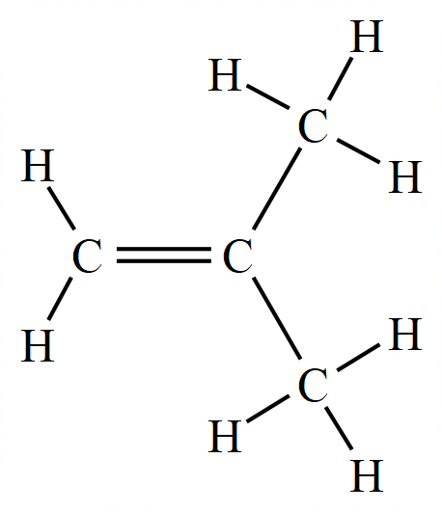
Give the IUPAC name of this compound.
(1 mark)

(b) Draw a full structural formula and give the IUPAC name for two geometric isomers of the compound. (4 marks)
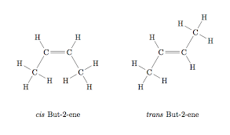

(c) Write balanced equation for the reactions of the compound shown in part (a), C₄H₈, in limited oxygen:
(2 marks)

Question 28 (6 marks)

The table below summarizes the isotopic composition for argon and potassium:

Element | Atomic Number | Relative atomic Mass | Relative abundance (%)
Argon | 18 | 35.978 | 0.307
Argon | 18 | 37.974 | 0.060
Argon | 18 | 39.974 | 99.633
Potassium | 19 | 38.975 | 93.300
Potassium | 19 | 39.976 | 0.011
Potassium | 19 | 40.974 | 6.690

(a) Determine the relative atomic mass of argon and potassium
(2 marks)

- Explain why the relative atomic mass of argon is larger than that of potassium even though potassium has a larger atomic number
(2 marks)

- ©Account for any slight discrepancies between the calculated atomic masses and those stated in the data sheet for argon and potassium.
(2 marks)

Question 29 (8 marks)

The solubility in water of cobalt (II) nitrate hexahydrate (Co(NO₃)₂.6H₂O) is approximately 134 g/100 mL at 25 ºC.

- DDetermine the concentration of cobalt ions (in mol L⁻¹) when 241 g of solid Co(NO₃)₂.6H₂O is agitated in 150 mL of distilled water at 25ºC – assume no volume change by the displacement by the solid.
(3 marks)

- StState and explain why this combination of compounds can be classified as saturated, unsaturated or supersaturated?
(2 marks)

(c) Describe all the types of bonding present between particles in the solution of
cobalt (II) nitrate hexahydrate.
(3 marks)

Question 30 (6 marks)
Provide full descriptions of what would be observed (including colours of solids/solutions, odours or gases produced) as well as a balanced equation showing only species that participate for the following reactions.

(a) small pieces of nickel metal are placed in 2 mol L⁻¹ hydrobromic acid (HBr).
(3 marks)

(b) A 2 g sample of powdered copper carbonate is treated with excess 1.0 mol L⁻¹ hydrochloric acid
(3 marks)

Question 31 (8 marks)
Calculate the pH of the following solutions:

(a) 1.93 x 10⁻⁴ mol L⁻¹ hydrochloric acid (1 mark)

(b) 0.00875 mol L⁻¹ sodium hydroxide solution
(2 marks)

(c) A solution made by mixing 25.0 mL of 6.68 x 10⁻⁴ mol L⁻¹ sulfuric acid and 15.0 mL of 8.31 x 10⁻⁵ mol L⁻¹ potassium hydroxide solution, giving your answer to the appropriate number of significant figures.
(5 marks)

Question 32 (12 marks)

The following table gives some information about several elements in the fourth row of the periodic table:

Element | Melting Point  (ºC) | Electrical conductivity | Melting point of its chloride (ºC)
Potassium | 63 | Very High | KC = 770
Chromium | 1857 | High | CrC₃ = 1150
Selenium | 221 | Low | SeC₄ = - 69
Bromine | -7 | Non-conductive | BrC = - 66

(a) Describe the type of bonding that is present in each of the row four elements that account for the range of melting points.
(4 marks)

(b) Using labelled diagrams describe the electrical conductivity of potassium and bromine (as Br₂).
(4 marks)

(c) Using labelled diagrams account for the data that is given for the differing melting points between the chlorides of potassium and bromine.
(4 marks)

Question 33 (8 marks)

Nitrogen dioxide can be prepared from the addition of concentrated nitric acid with pure copper metal:

Cu (s) + 4 HNO₃ (aq) → Cu(NO₃)₂ (aq) + 2 H₂O (ℓ) + 2 NO₂ (g)

(a) Determine the Limiting Reagent when 150.0 mL of 14.0 mol L⁻¹ HNO₃ and 242 g of copper metal are combined at STP.
(4 marks)

- Calculate the volume of nitrogen dioxide that would be generated at STP from this reaction.
(1 mark)

I Calculate the mass of unused reactant that remains after this reaction has gone to completion.
(3 marks)

End of Section Two
Section Three: Extended answer 40% (80 Marks)

This section contains 5 questions. You must answer all questions. Write your answers in the spaces provided.

Where questions require an explanation and/or description, marks are awarded for the relevant chemical content and also for coherence and clarity of expression. Lists or dot points are unlikely to gain full marks.

Final answers to calculations should be expressed to the appropriate number of significant figures.

Spare pages are included at the end of this booklet. They can be used for planning your responses and/or as additional space if required to continue an answer.
• Planning: If you use the spare pages for planning, indicate this clearly at the top of the
page.
• Continuing an answer: If you need to use the space to continue an answer, indicate in the original answer space where the answer is continued, i.e. give the page number. Fill in the number of the question(s) that you are continuing to answer at the top of the page.

Suggested working time: 70 minutes.

Question 34 (22 marks)

The Pilbara region in Western Australia is one of the leading iron ore producing areas in the world. The ore that is mined contains a number of minerals, including hematite, magnetite, and titano-magnetite.

The development of coke blast furnaces (as opposed to charcoal) in 1709 enabled much more efficient extraction of iron ores. This method of extraction changed relatively little up to the 21st century. Kwinana is now the site of a new HIsmelt iron production plant, which, it is envisaged, will one day produce up to 800,000 tonnes of iron each year.

The technology promises to offer a lower cost and cleaner alternative to the traditional blast furnace process, but the chemical reactions taking place are largely similar. In the smelter, fine iron ore and coal are injected directly into a bath of molten iron. Here, the carbon dissolves in the molten metal, and reacts with iron oxides to produce iron and carbon monoxide at about 1450ºC.

The equation for the reaction taking place between the carbon and iron oxide is below:.

Fe₂O₃ (s) + 3 C (s) → 2 Fe () + 3 CO (g)

The diagram below shows the design of a HIsmelt furnace.

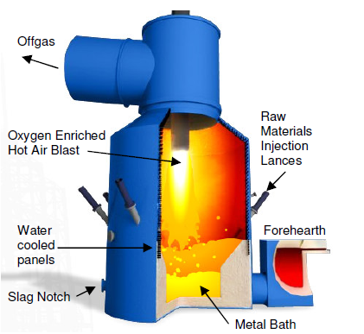

- Explain, using collision theory, why it is important that the iron ore and coke are finely divided when they enter the molten iron bath at the bottom of the furnace.
(2 marks)

The rapid expulsion of carbon monoxide causes a fountain of molten metal and slag droplets to rise up inside the furnace. A hot air blast is used to combust the carbon monoxide released by the bath reactions. The air in the blast is enriched with up to 35% oxygen to aid this combustion.

- Explain, using collision theory, what effect the enrichment of the oxygen content has on the rate of reaction between the gases.
(2 marks)

The equation for the reaction between carbon monoxide and oxygen is shown below:

2CO_{(g)} + O_{2(g)}→ 2CO_{2(g)} ∆H = - 566 kJmol⁻¹

- On the axes below, draw an energy level diagram for the reaction. Ensure that you label the axes, reactants and products, and the enthalpy change clearly.
(3 marks)

It is important that the air in the blast is heated to ensure a satisfactory rate of reaction between the gases in the smelter. The following graph shows the energies of molecules in the gas mixture at temperatures such as those used (around 1450ºC).

- Sketch on the graph what effect using a lower temperature would have on the energy of the particles. (1 mark)

% of particles

1450ºC

Kinetic energy (kJ)

- Use the data from the graph in part (d) to explain why the rate would be slower if the blast were not heated.
(3 marks)

One of the advantages of the HIsmelt process compared to traditional blast furnace methods of extraction is the flexibility it offers with regard to ores used, meaning less processing is required. 1000 kg of direct shipping iron ore, containing 65% Fe₂O₃, is fed into the furnace, together with 200 kg of coal.

- Find the limiting reagent (assume the coal is 100% carbon). (5 marks)

- What mass of molten iron would be formed in the reaction?
(2 marks)

- The smelter is run at 120 kPa and 1450ºC. What volume of carbon monoxide would form in the smelter if the volume of carbon monoxide at these conditions occupies 119.4 L mol⁻¹ ?
(2 marks)

- What volume of enriched air would need to be blasted into the furnace to provide the oxygen for the combustion of this carbon monoxide (you may assume the air is at the same temperature and pressure as the gases in the furnace)? (2 marks)

Question 35 (13 marks)

Caproic acid is the chemical responsible for the smell of dirty socks and is composed of carbon, hydrogen and oxygen only. It is a weak, monoprotic acid. A 0.531 g sample of the acid was combusted to produce 1.21 g of carbon dioxide and 0.493 g of water.

(a) Determine the empirical formula for the acid
(6 marks)
(b) Given that the molar mass of caproic acid is 116 g mol⁻¹, determine the molecular formula of the acid.
(3 marks)

- ©Zinc oxide can be used as a foot powder to reduce the smell. Write an equation for the reaction between zinc oxide and caproic acid solution. Hint: caproic acid is monoprotic.
(2 marks)

- Caproic acid, like ethanoic acid is considered a weak acid. Explain why this is the case and what affect this has on the concentration of hydrogen ions that are available to react.
(2 marks)

This page has been left blank intentionally

Question 36 (25 marks)

Barium is a highly toxic substance to higher animals and can accumulate in animal and plant tissue. High barium levels can affect the ability of plants to photosynthesize, and in higher animals can cause heart disease, respiratory failure, kidney damage, and muscle weakness. Student chemists were interested in determining the concentration of barium (II) ions in a large water pond outside of a glass making factory.

The basic technique involved adding sodium sulfate (Na₂SO₄) to a 500.0 mL water sample to precipitate out the barium as barium (II) sulfate. The acceptable level of barium in drinking water is 2.0 mg/L. Levels above 50 mg/L are considered to be immediately dangerous to life and health.

- Write a balanced equation (containing only species participating) for the precipitation reaction.
(1 mark)

The barium sulfate precipitate was collected and placed in a special oven at 110ºC. Over time the sample was weighed and re-weighed. (1 g = 1000 mg)
Weighing | Mass (mg)
1 | 23.0
2 | 21.5
3 | 19.0
4 | 19.0

- Why was the sample weighed four times?
(1 mark)

- ©Calculate the mass of barium in mg in the precipitate. (2 marks)

(d) Determine the concentration of barium ions (in mg/L), in the polluted water sample. (Assume the density of the water is 1000 mg/L)
(2 marks)

- IHow does the concentration of barium ions in the water sample compare with the accepted level in drinking water?
(1 mark)

(f) The students assumed that no other ions in the water formed precipitates with the sodium sulfate solution.

(i) Name ONE other ion that would also form a precipitate with sulfate ions? (1 mark)

(ii) Write the balanced ionic equation for the reaction of this ion that forms a precipitate with sodium sulfate solution. (2 marks)

After this preliminary result, the students decided to extend their investigation over a number of weeks to see how barium levels changed over time, and so tested more water samples. Their results are tabulated below:

Day | Concentration of Barium ions (mg/mL)
0 | Answer in (d)
3 | 30
6 | 36
9 | 45
12 | 60
15 | 55
18 | 58

(g) For this extended investigation what was the:
(2 marks)

(h) State two (2) variables that would need to be controlled? (2 marks)

(i) What safety measures should be used when handling the barium samples?
(2 marks)

- Plot the information on the graph paper below. Include a heading and all labels.
(5 marks)

(k) What conclusions can be made from this investigation?
(2 marks)

(l) Describe TWO possible impacts on the environment that high levels of barium from this factory may have?
(2 marks)

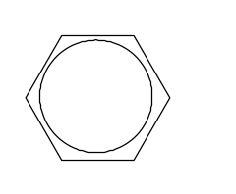
Question 37 (20 marks)
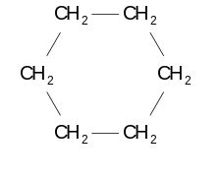

Benzene (C₆H₆) can be converted to cyclohexane (C₆H₁₂)

by the addition of hydrogen gas. The reaction can be catalysed using metallic nanoparticles.

(a) Using kinetic theory and an appropriate diagram, explain how a catalyst can speed up the rate of the chemical reaction.
(4 marks)

(b) Using collision theory, explain why the metal catalyst is more effective in the form of nanoparticles than in the bulk form (larger pieces) of the metal.
(2 marks)

(c) Write a balanced chemical equation for this reaction.
(1 mark)

(d) Calculate the mass of cyclohexane that can be produced from 1750 g of benzene.
(3 marks)

I (i) Calculate the mass of hydrogen gas that would be required for this reaction.
(2 marks)

(ii) Calculate the volume of this amount of hydrogen gas at standard temperature and pressure (STP).
(2 marks)

(f) During this process, the chemical engineer was concerned that cyclohexene (C₆H₁₀) might be formed in place of the cyclohexane.

(i) Describe a chemical test, including expected observations, that would detect the presence of cyclohexene in the products of this reaction.
(2 marks)

(ii) With reference to the equation in part (c), suggest how the chemical engineer can reduce the risk of cyclohexene being formed in the reaction.
(1 mark)

(g) The percentage by mass of carbon in cyclohexane is 85.8%

(i) Calculate the percentage by mass of carbon in benzene
(1 mark)

(ii) Use you answer to (g) (i) to suggest why aromatic substances such as benzene burn with a more smoky flame than aliphatic compounds such as cyclohexane.
(2 marks)

End of questions
Additional Working Space

__________________________________________________________________________________________

__________________________________________________________________________________________

__________________________________________________________________________________________

__________________________________________________________________________________________

__________________________________________________________________________________________

__________________________________________________________________________________________

__________________________________________________________________________________________

__________________________________________________________________________________________

__________________________________________________________________________________________

__________________________________________________________________________________________

__________________________________________________________________________________________

__________________________________________________________________________________________

__________________________________________________________________________________________

__________________________________________________________________________________________

__________________________________________________________________________________________

__________________________________________________________________________________________

__________________________________________________________________________________________

__________________________________________________________________________________________

__________________________________________________________________________________________

__________________________________________________________________________________________

__________________________________________________________________________________________

__________________________________________________________________________________________

__________________________________________________________________________________________

__________________________________________________________________________________________

__________________________________________________________________________________________

Spare grid for Question 36

Additional Working Space

__________________________________________________________________________________________

__________________________________________________________________________________________

__________________________________________________________________________________________

__________________________________________________________________________________________

__________________________________________________________________________________________

__________________________________________________________________________________________

__________________________________________________________________________________________

__________________________________________________________________________________________

__________________________________________________________________________________________

__________________________________________________________________________________________

__________________________________________________________________________________________

__________________________________________________________________________________________

__________________________________________________________________________________________

__________________________________________________________________________________________

__________________________________________________________________________________________

__________________________________________________________________________________________

__________________________________________________________________________________________

__________________________________________________________________________________________

__________________________________________________________________________________________

__________________________________________________________________________________________

__________________________________________________________________________________________

__________________________________________________________________________________________

__________________________________________________________________________________________

__________________________________________________________________________________________

__________________________________________________________________________________________

Additional Working Space

__________________________________________________________________________________________

__________________________________________________________________________________________

__________________________________________________________________________________________

__________________________________________________________________________________________

__________________________________________________________________________________________

__________________________________________________________________________________________

__________________________________________________________________________________________

__________________________________________________________________________________________

__________________________________________________________________________________________

__________________________________________________________________________________________

__________________________________________________________________________________________

__________________________________________________________________________________________

__________________________________________________________________________________________

__________________________________________________________________________________________

__________________________________________________________________________________________

__________________________________________________________________________________________

__________________________________________________________________________________________

__________________________________________________________________________________________

__________________________________________________________________________________________

__________________________________________________________________________________________

__________________________________________________________________________________________

__________________________________________________________________________________________

__________________________________________________________________________________________

__________________________________________________________________________________________

__________________________________________________________________________________________

